Testing Document

### Tool used for testing: Ghost inspector

### Story 011: The ability to browse the media by key phase (Basic search function)

Expected result:

* The users will be able to search their desired media by entering the name/title in the search box. They can also view the list of results as soon as they start typing the first letter.

# Result:

The results have met the acceptance criteria listed above.

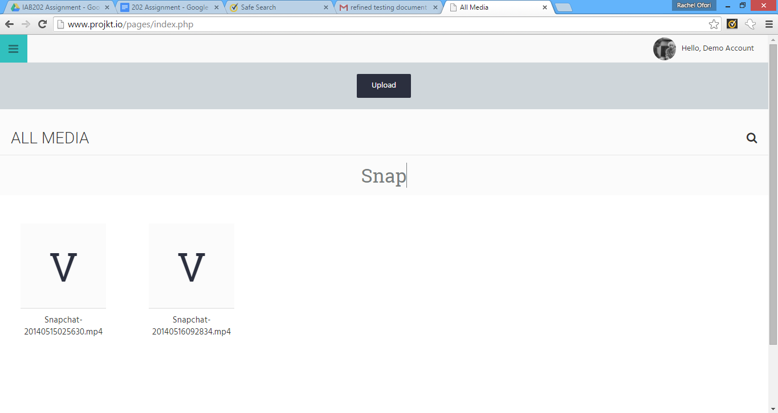

### Story 06: The ability to use advanced search functionality within the same page- live search

Expected result:

* The users will be able to search their desired media by entering the name/title in the search box. They can also view the list of results as soon as they start typing the first letter

# Result:

The results have met the acceptance criteria listed above.

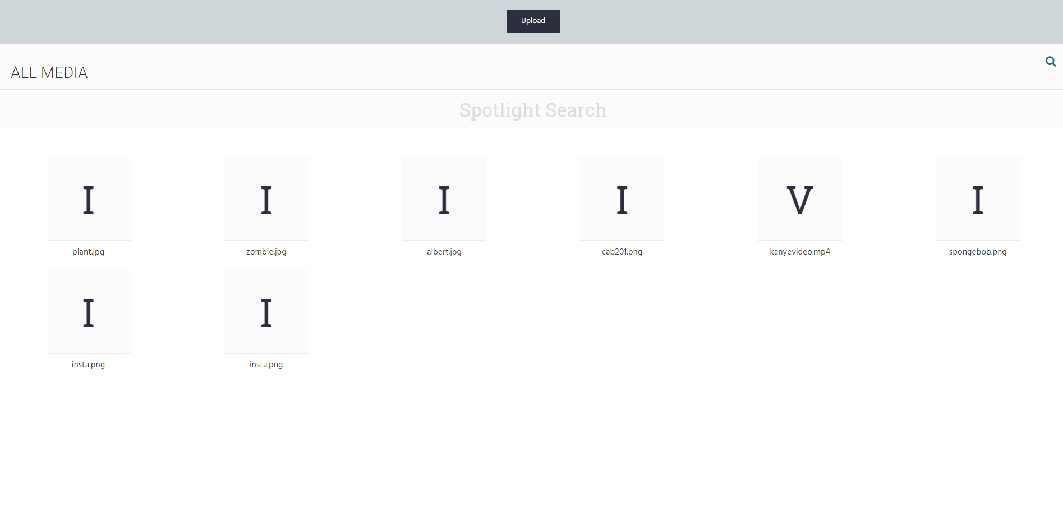

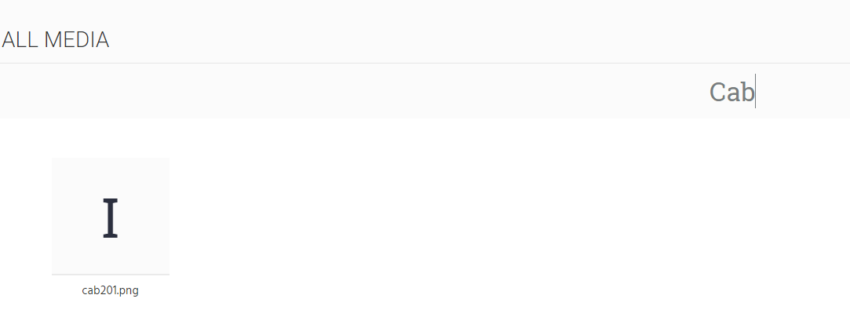

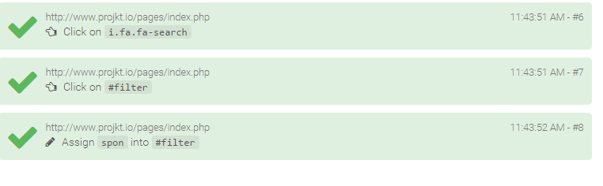

### Story 02: The ability to delete the media

Expected result:

* The logged in user will be able to upload their media to the account.
* The user will be able to upload the items by browsing their devices.

# Result:

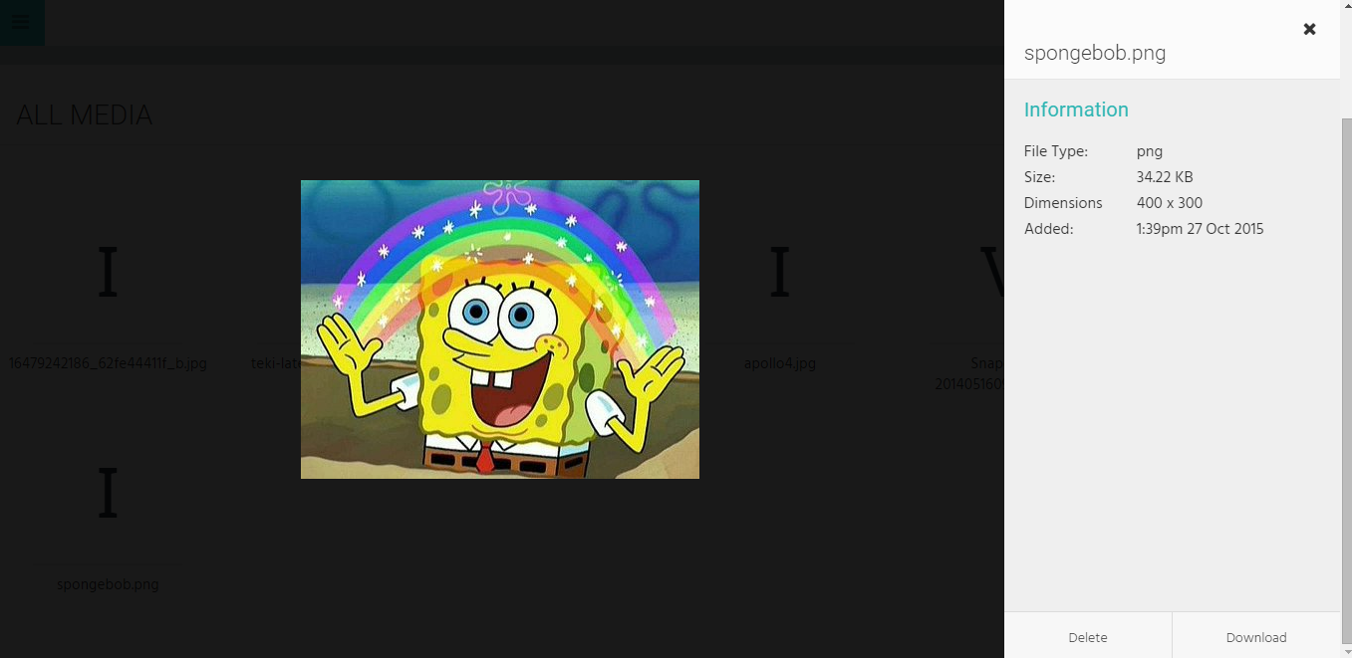The results have met the acceptance criteria listed above.

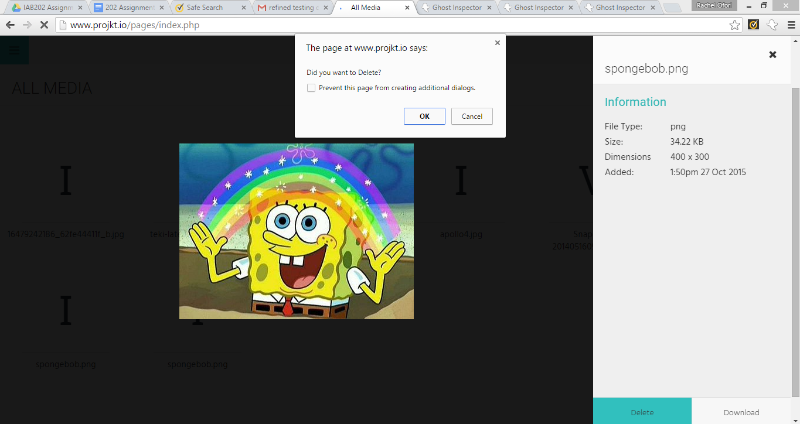

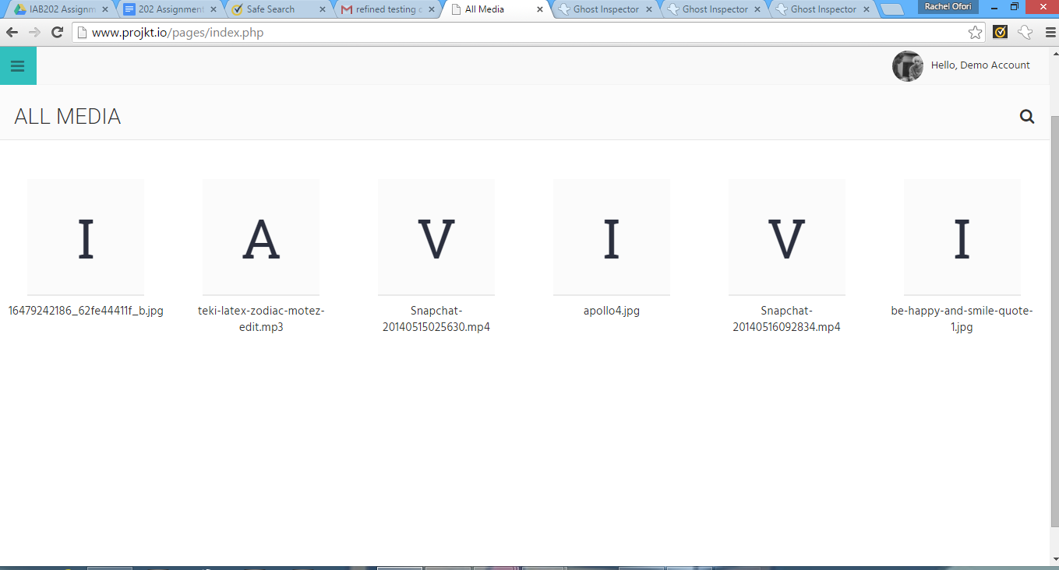

### Story 013: The ability for the user to view the metadata of their media items

Expected result:

* The user will be able to view the thumbnails of the media on the home page with brief details about the particular media before it is downloaded

# Result:

The results have met the acceptance criteria listed above.

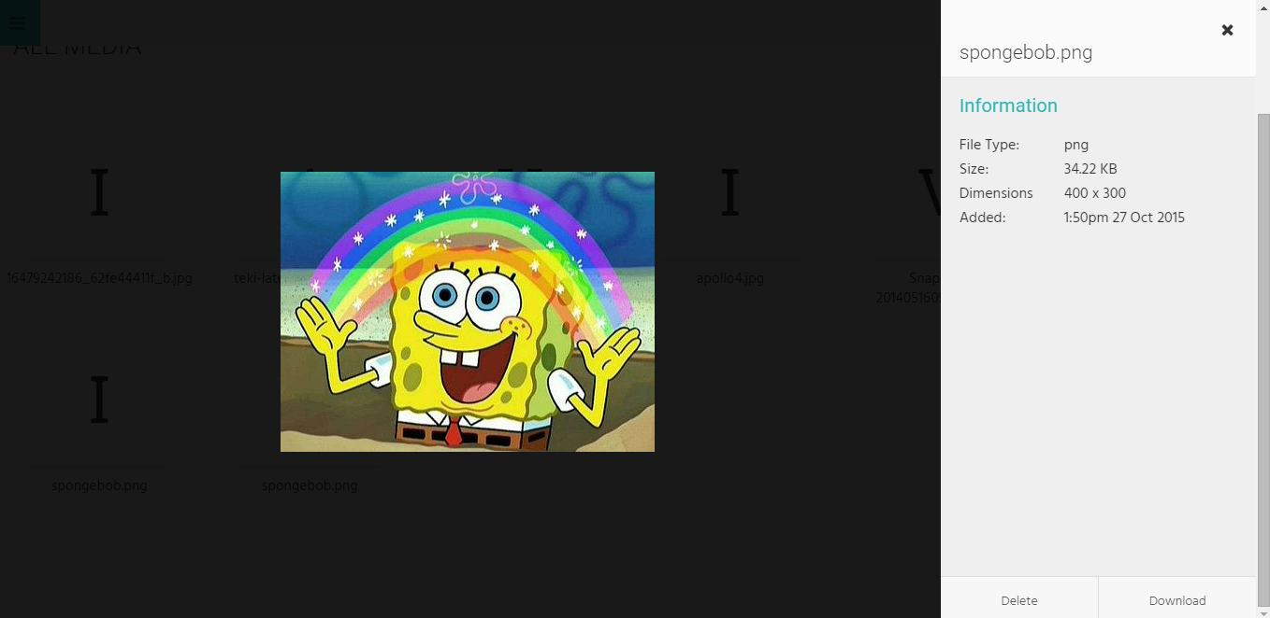

### 

### Story 017: The ability to view the general media library on the home page

* The users will be able to view their uploaded media on the home page.

# Result:

The results have met the acceptance criteria listed above.

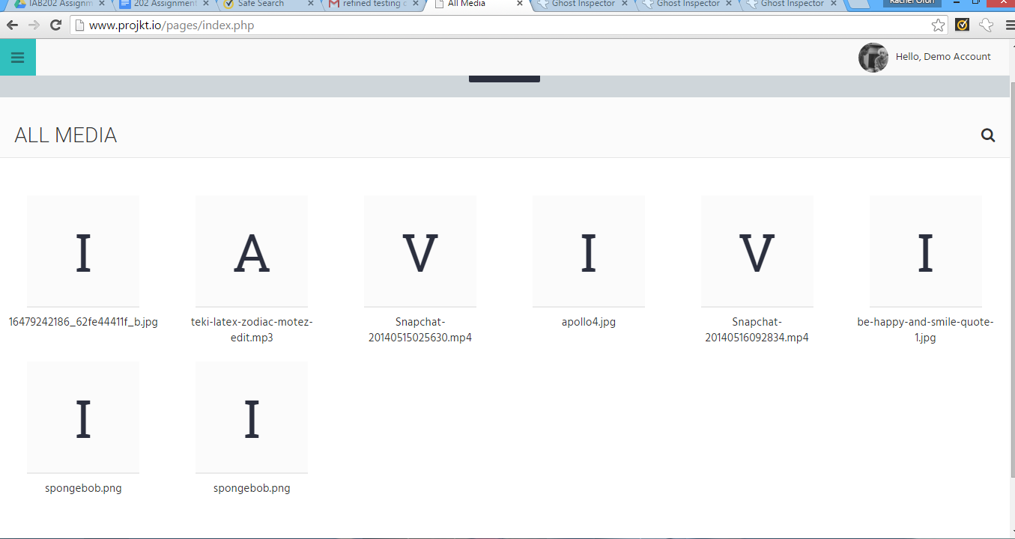

### Story 015: The ability for the user to view the images and stream video from within the website

Expected result:

* The user will be able to preview the media prior to downloading it to their devices

# Result:

The results have met the acceptance criteria listed above.

